ECOR 1010 - DAY 3

Engineering Reporting & Measurements, Dimensions and Units.
- Date and Sign Everything Written
- Be clear and concise
- Avoid Jargon and Fancy Words
- Plan content – Outline – Several Drafts
- Spell Checkers are only an aid
- Do NOT leave writing to the last minute
- PROOFREAD OVER AND OVER
- Minimize Number of Words
- Avoid Verbs turned into Nouns
- “Determination of procedure occurs at the committee level.”
“The committee determines the procedure.”
- Use Strong Subjects
- “The decision was made by the supervising engineer.”
“The supervising engineer made the decision.”
- Useless Adverbs
- “The project was completed really well”
“The project was completed well.”
ECOR 1010 Lab Reports
• One page of text, plus front (title page) and back
matter (appendices)
• Typed and neatly formatted
• Use Course Template: 12-point font size with fixed
margins all around
• Drawings, tables, and graphs should be attached
to the report as Appendices
• Drawings, tables and graphs should be supported
by a short statement describing purpose and
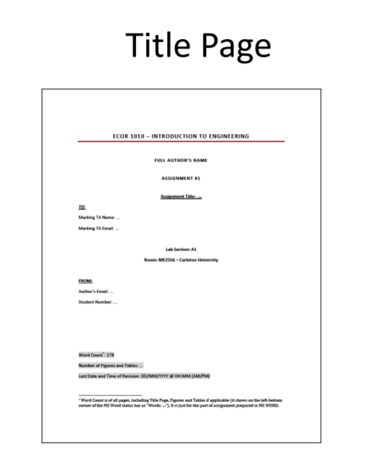
content (i.e., a caption)
One Page of Text
• Introduction
– background information, concise statement of technical objective
• Method
– procedure to investigate objective
• Results & Discussion
– present results related to objective clearly, refer to graphs, tables or
drawing as required
– details in Appendix
– discuss difficulties or anomalies and significance of results
• Conclusions
– list specific significant conclusions
– state if objective achieved
All Figures and Tables referred to in one page of text must
be numbered and have a caption
Appendices
• Sketches, drawings, tables, calculations, etc. and supporting text that provide additional detail to results.
• Each Appendix referred to individually in Results section
• But, each sketch, drawing, table, etc. in the Appendix does not have to be referred to individually in Results section.

